Script and Results – Kings college of London
import os
import nibabel as nib # For NIfTI files
import matplotlib.pyplot as plt
import numpy as np
from PIL import Image # For PNG/JPG images

# Set your data directory
data_dir = "E:/BRAIN_IIT/kings college london/SpinaBifidaAtlas_v2"
folders = [f for f in os.listdir(data_dir) if os.path.isdir(os.path.join(data_dir, f))]
print("Available folders:", folders)

Available folders: ['fetal_SB_atlas_GA21_notoperated', 'fetal_SB_atlas_GA22_notoperated', 'fetal_SB_atlas_GA23_notoperated', 'fetal_SB_atlas_GA24_notoperated', 'fetal_SB_atlas_GA25_notoperated', 'fetal_SB_atlas_GA25_operated', 'fetal_SB_atlas_GA26_operated', 'fetal_SB_atlas_GA27_operated', 'fetal_SB_atlas_GA28_operated', 'fetal_SB_atlas_GA29_operated', 'fetal_SB_atlas_GA30_operated', 'fetal_SB_atlas_GA31_operated', 'fetal_SB_atlas_GA32_operated', 'fetal_SB_atlas_GA33_operated', 'fetal_SB_atlas_GA34_operated']

folder = 'fetal_SB_atlas_GA21_notoperated'
folder_path = os.path.join(data_dir, folder)
contents = os.listdir(folder_path)
print("Files in", folder, ":", contents)

Files in fetal_SB_atlas_GA21_notoperated : ['lmks.nii.gz', 'mask.nii.gz', 'parcellation.nii.gz', 'srr.nii.gz']
import os
import nibabel as nib
import matplotlib.pyplot as plt

folder = 'fetal_SB_atlas_GA21_notoperated'
folder_path = os.path.join(data_dir, folder)

# Load images
img = nib.load(os.path.join(folder_path, 'srr.nii.gz')).get_fdata()
mask = nib.load(os.path.join(folder_path, 'mask.nii.gz')).get_fdata()
parc = nib.load(os.path.join(folder_path, 'parcellation.nii.gz')).get_fdata()

# Visualize central slice from each (you can change axis for coronal/sagittal)
central_slice = img.shape[2] // 2

plt.figure(figsize=(15, 5))
plt.subplot(1, 3, 1)
plt.imshow(img[:, :, central_slice], cmap='gray')
plt.title('Super-Resolution MRI')
plt.axis('off')
plt.subplot(1, 3, 2)
plt.imshow(mask[:, :, central_slice], cmap='gray')
plt.title('Brain Mask')
plt.axis('off')
plt.subplot(1, 3, 3)
plt.imshow(parc[:, :, central_slice], cmap='nipy_spectral')
plt.title('Parcellation')
plt.axis('off')
plt.show()
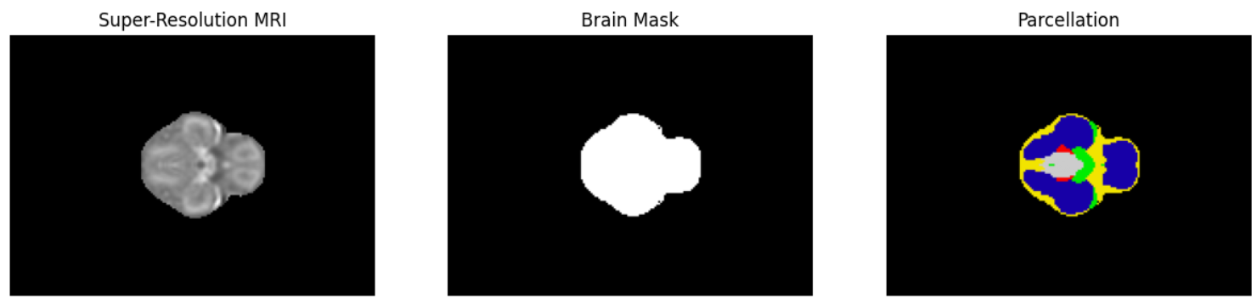

import os
import numpy as np
import pandas as pd
import nibabel as nib

# Set path to data directory
data_dir = "E:/BRAIN_IIT/kings college london/SpinaBifidaAtlas_v2"
folders = [f for f in os.listdir(data_dir) if os.path.isdir(os.path.join(data_dir, f))]
results = []

for folder in folders:
folder_path = os.path.join(data_dir, folder)
parc_path = os.path.join(folder_path, 'parcellation.nii.gz')
if os.path.exists(parc_path):
parc = nib.load(parc_path)
parc_data = parc.get_fdata()
# Get unique region labels (excluding background 0)
region_labels = np.unique(parc_data)[1:]
region_counts = [(label, np.sum(parc_data == label)) for label in region_labels]
for label, count in region_counts:
results.append({
'Folder': folder,
'Gestational_Age': ''.join([c for c in folder if c.isdigit()]), # e.g., 21
'Operated': 'operated' in folder,
'Region_Label': int(label),
'Voxel_Count': int(count)
})

# Convert to DataFrame
df = pd.DataFrame(results)
# Optional: Compute total brain volume per case
total_per_case = df.groupby('Folder')['Voxel_Count'].sum().reset_index().rename(columns={'Voxel_Count': 'Total_Brain_Volume'})
print(df.head())
print(total_per_case.head())

# Save to CSV for further plotting or reporting
df.to_csv("spina_bifida_region_volumes.csv", index=False)
total_per_case.to_csv("spina_bifida_total_volumes.csv", index=False)

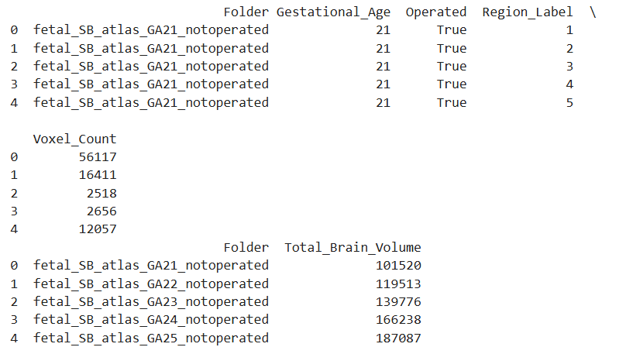

import matplotlib.pyplot as plt

# Assuming total_per_case DataFrame from earlier code
plt.figure(figsize=(8,5))
plt.plot(total_per_case['Folder'], total_per_case['Total_Brain_Volume'], marker='o')
plt.xticks(rotation=45)
plt.xlabel("Folder (Gestational Age)")
plt.ylabel("Total Brain Volume (voxels)")
plt.title("Fetal Brain Volume Increases with Gestational Age")
plt.tight_layout()
plt.show()

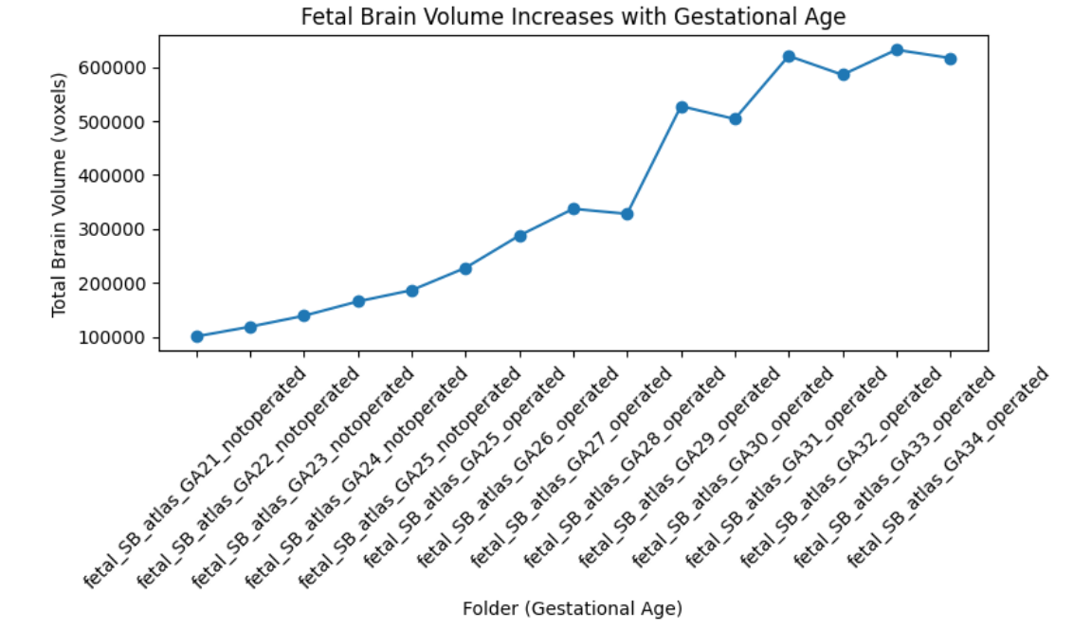

import pandas as pd
import numpy as np
from scipy.stats import pearsonr

# Load or reuse your 'total_per_case' dataframe

# Extract gestational ages as integers
total_per_case['Gestational_Age'] = total_per_case['Folder'].str.extract(r'GA(\d+)').astype(int)

# Summary statistics
mean_vol = total_per_case['Total_Brain_Volume'].mean()
std_vol = total_per_case['Total_Brain_Volume'].std()

# Correlation (Pearson)
corr, p_val = pearsonr(total_per_case['Gestational_Age'], total_per_case['Total_Brain_Volume'])

print(f"Mean brain volume: {mean_vol:.2f}")
print(f"Std deviation: {std_vol:.2f}")
print(f"Correlation (r) with gestational age: {corr:.2f} (p-value: {p_val:.4f})")

# Optional: regression fit
import matplotlib.pyplot as plt
from numpy.polynomial.polynomial import Polynomial

x = total_per_case['Gestational_Age']
y = total_per_case['Total_Brain_Volume']

coefs = np.polyfit(x, y, 1)
fit_line = coefs[0]*x + coefs[1]
plt.figure(figsize=(8,5))
plt.scatter(x, y)
plt.plot(x, fit_line, color='red', label=f'Linear fit (slope={coefs[0]:.1f})')
plt.xlabel("Gestational Age (weeks)")
plt.ylabel("Total Brain Volume (voxels)")
plt.title("Brain Volume vs Gestational Age with Trend Line")
plt.legend()
plt.show()

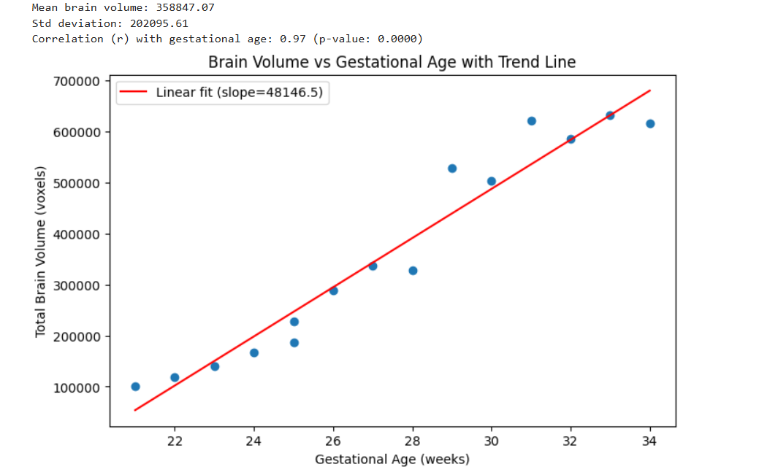

total_per_case = total_per_case.sort_values('Gestational_Age')
growth = total_per_case['Total_Brain_Volume'].diff()
mean_growth = growth.mean()
print(f"Mean weekly brain volume increase: {mean_growth:.2f} voxels")
print("Weekly growth at each step:", growth.values)

from scipy.stats import ttest_ind

operated = total_per_case[total_per_case['Folder'].str.contains('operated')]['Total_Brain_Volume']
not_operated = total_per_case[~total_per_case['Folder'].str.contains('operated')]['Total_Brain_Volume']

t_stat, p_val = ttest_ind(operated, not_operated, equal_var=False)
print(f"Operated mean: {operated.mean():.2f}, Not-operated mean: {not_operated.mean():.2f}")
print(f"T-test: t={t_stat:.2f}, p={p_val:.4f}")

plt.hist(total_per_case['Total_Brain_Volume'], bins=8)
plt.xlabel("Total Brain Volume (voxels)")
plt.ylabel("Number of Cases")
plt.title("Distribution of Fetal Brain Volumes")
plt.show()

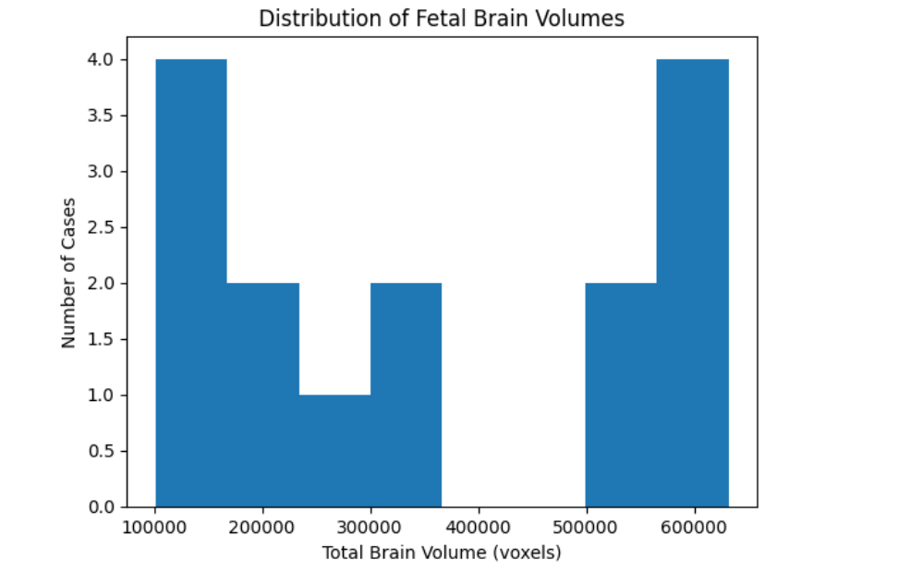

z_scores = (total_per_case['Total_Brain_Volume'] - mean_vol) / std_vol
outliers = total_per_case[np.abs(z_scores) > 2]
print("Outlier cases:", outliers[['Folder', 'Total_Brain_Volume']])

